Name _______________________ Date _________
Herpetologist Note Catcher
Learning Target: I can observe key details in a photograph and ask who, what, where, when, why, and how questions.

Observations  (I see . . . . . . . . . ) | Questions  (I wonder . . .) Use the words who, what, where, when, why, how

INFERENCES
Based on your observations and questions, can you guess what a herpetologist is or does? On what key details do you base your inference?

I think a herpetologist ___________________________________

because ______________________________________________.

I think a herpetologist ___________________________________

because ______________________________________________.

I think a herpetologist ___________________________________

because ______________________________________________.

I think a herpetologist ___________________________________

because ______________________________________________.
Mystery Image #1
Hi. My name is Susan. I’m studying to be a herpetologist. Some people call us herpers.

Can you guess what I do?
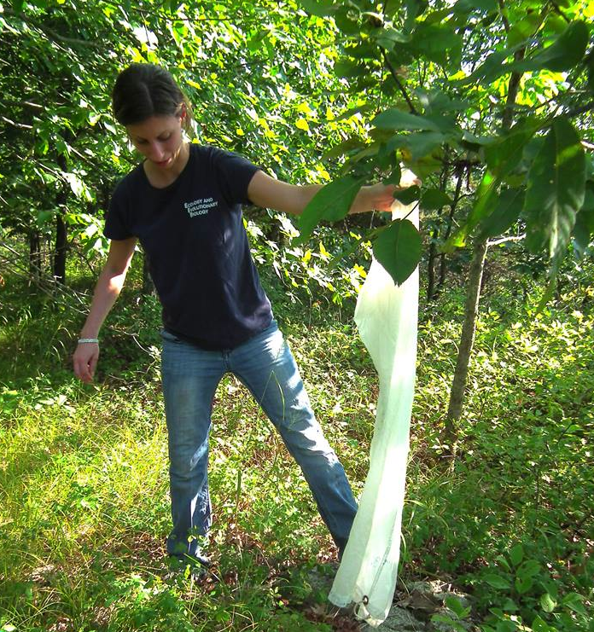
Used with permission of the Copperhead Institute, http://www.copperheadinstitute.org
Clue 1
What Tools and Equipment Does a Herpetologist Use?
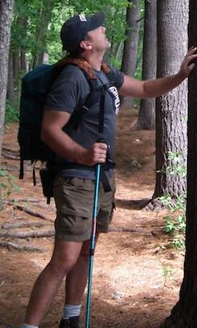
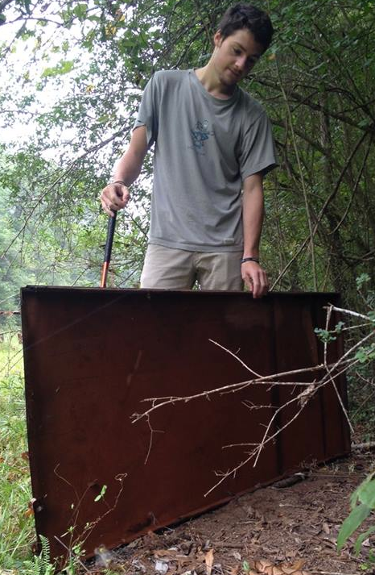
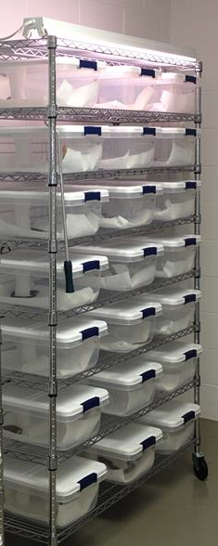
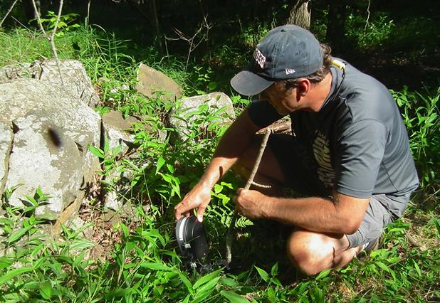

Metal cover board Pole Cage

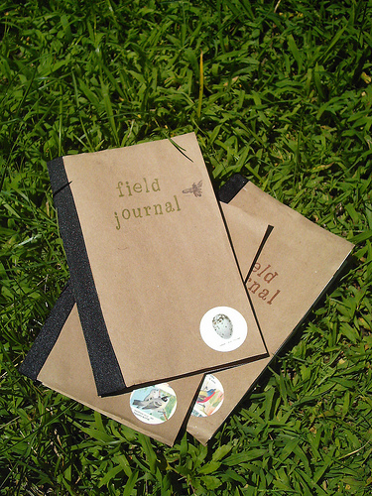

Time-lapse camera Field journal

Clue 2
Where Does a Herpetologist Work?

zoos  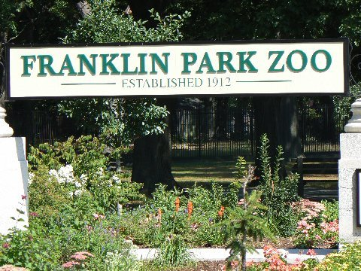 | museums  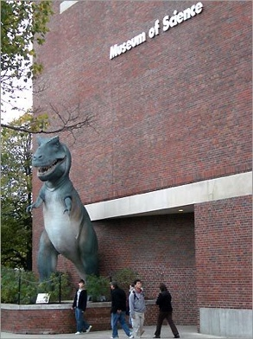
parks  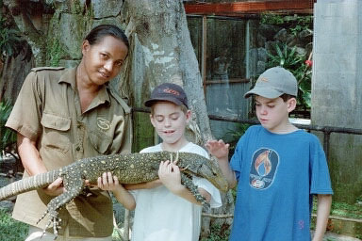 | universities
crocodile farms
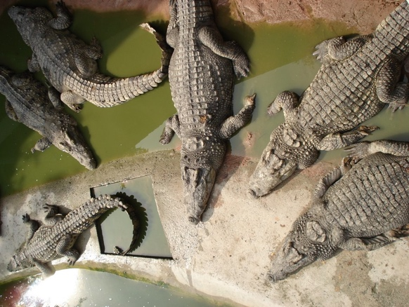

Clue 3
What Does a Herpetologist Do?

1. Herpetologists are scientists.

2. Herpetologists do research.

3. Herpetologists do lots of fieldwork.

4. Herpetologists observe how certain animals behave.

5. Herpetologists conduct food supply studies.

6. Herpetologists sometimes look for new species.

7. Some herpetologists teach.

8. Herpetologists write reports.
Clue 4
Take Apart the Word

Learning Target: I can decode the meaning of an unfamiliar word by looking at the meaning of the suffix.

1. Look at the root word: herpe.
- A root word is a word that you can make new words from
by adding beginnings (prefixes) or endings (suffixes).
- Look at the suffix, or the ending of the word.
- Put the root and the suffix together and find the meaning
of the word.
Herpetologist

Suffix: ologist
Means: someone who studies

Root: herpe
Means: creeping animal

+

A herpetologist is:

Mystery Image #2
Guess the Animal

We are going to be herpetologists! We are going to study one type of reptile. Look at the images below. What type of reptile do you think we will be studying?

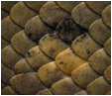

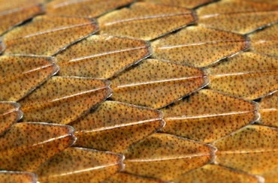

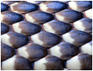

Name _______________________ Date _________
What Do You Think About Snakes?
Learning Target: I can reflect on my attitude about snakes.

Read the statements below. Next to each statement,
check whether you agree or disagree.

Statements about snakes | Agree | Disagree
Snakes are mean.
Snakes are ugly and gross.
Snakes are slimy.
Most snakes are poisonous and dangerous.
Endangered species like pandas and whales should be saved before we save endangered snakes.
Snakes should be killed because they are scary.
Snakes are not good pets.

Name _______________________ Date _________

Creating a Survey Scale

Circle ONE statement in each category that you think represents the category best.

1 | I love snakes SO much, if a snake crawled in my bed, I’d kiss it.  I love snakes so much I want a pet corn snake.  I’m not scared of snakes. I’d let a snake slither on my head.
2 | I will pet a snake, but not let it sleep with me.  I would let a snake crawl on me, but not for very long.  I am fine with some snakes and scared of some snakes.  I like some snakes, but hate poisonous snakes.
3 | I am scared of snakes, but I won’t faint if I see one.  I can look at a snake, but not for very long.  If I found a snake, I would wet my pants.
4 | I hate snakes so much, I want to kill them.  I hate snakes so much I would move to Jupiter and would rather eat a dragon than look at a snake.  Every time I see a snake, I panic.  I am so scared, that if I see a snake, I will blow up and scream in a number-4 voice.

Name _______________________ Date _________

Survey: Are You Scared of Snakes?

Please rate how scared you are of snakes, on a 1 to 4 scale. Circle the one rating that fits you best.

1  I love snakes SO much, if a snake crawled in my bed, I’d kiss it. | 2  I would let a snake crawl on me, but not for long. | 3  I am scared of snakes, but I won’t faint if I see one. | 4  Every time I see a snake, I panic. I hate snakes so much I would move to Jupiter. I would rather eat a dragon than look at a snake.

If you rated yourself a 3 or a 4, please explain why you are scared of snakes.

What Makes a Snake a Snake?
Section 1
What is long and round and slides on the ground? What can be fat or thin, and has dry, scaly skin? A snake! A snake’s whole body is covered in scales. These scales are hard and tough like fingernails. A snake has scales on its belly that are larger than the ones on its back.

Section 2
Snakes have no legs. They move in long slinky curves. The ground may look smooth but it has little bumps everywhere. A snake pushes off the bumps to move itself forward.

Section 3
Snakes are cold blooded. This means their body temperature is always the same temperature as the air around it. To warm up, a snake lies in the sun. To cool down, a snake moves into the shade.

Snakes live in fields and forests. They live in deserts and oceans too. They even live in city parks. Snakes can live almost anywhere.

Section 4
Some snakes smell with their noses. But all snakes smell with their tongues. Their tongues are split at the tip. This helps them know if they should go left or right.

Section 5
Snakes grow quickly but their skin doesn’t stretch. When a snake’s skin gets too tight, the snake has to shed it. This is called molting. The snake rubs it head on something rough like a rock or a log. After a few minute, the skin begins to peel. The snake slides forward and right out of its skin. It looks bright and shiny. The snake keeps on growing.
Soon it will be time to molt.

Most snakes are hard to see. They blend in with their surroundings.
,

Adapted from Snakes by Melissa Stewart and Slinky Scaly Snakes by Jennifer Dussling

Snake Note Catcher
Learning Target: I can identify the main idea and supporting details in a read aloud text about snakes.
Circle one main idea: Physical Features Habitat Diet Predator and Defenses Life Cycle

Main Idea

